**"Marketplace Technical Foundation – Muniba e-shop"**

**1-Technical Requirements:**

**Frontend Requirements:**

o User-friendly interface for browsing products.

o Responsive design with carousel from shadcn-ui for mobile and desktop users.

o Essential pages: Home, Login/signup, Product Details, Cart, Checkout, and Order Confirmation, error 404 page not found page.

**Sanity CMS as Backend:**

o Use Sanity CMS to manage product data, customer details, and order records. Sanity acts as the database for my general ecommerce marketplace.

* Designing schemas of product, order, shipment, customer details with sanity.

**Third-Party APIs:**

o Integrate APIs for shipment tracking, payment gateways, and other required backend services using shipEngine for shipment and stripe for payment.

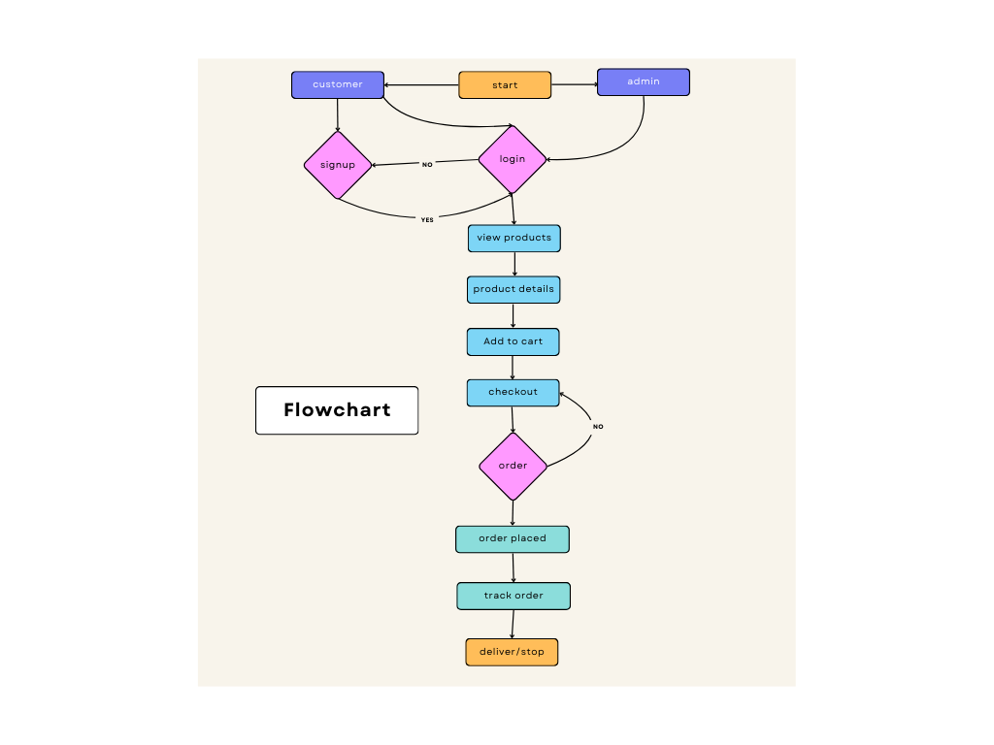

**2. Design System Architecture**

[Frontend (Next.js) Login/sign-up]

|

[view products ]

|

[Sanity CMS] ---------> [Product Data API]

|

[Third-Party API] -----> [Shipment Tracking API]

|

[Payment Gateway] ---->[stripe/easypaisa]

1. A user visits the marketplace frontend to browse products.
2. The frontend makes a request to the Product Data API (powered by Sanity CMS) to fetch product listings and details, which are displayed dynamically on the site.
3. When the user places an order, the order details are sent to Sanity CMS via an API request, where the order is recorded.
4. Shipment tracking information is fetched through a Third-Party API and displayed to the user in real-time.

|  |  |  |  |
| --- | --- | --- | --- |
| Endpoint Name | Method | Description | Response Example |
| /products | GET | Fetch all product details. | { "id": 1, "name": "Printed shirt", "price": 2000 } |
| /products | GET | Fetch all available products from Sanity. | Product details (ID, name, price, stock, image). |
| /orders | POST | Create a new order in Sanity. | Customer info, product details, payment status. |
| /shipment | GET | Track order status via third-party API. | Shipment ID, order ID, status, expected delivery date. |

1. Payment details are securely processed through the Payment Gateway, and a confirmation is sent back to the user and recorded in Sanity CMS.

**Work flow Diagram**

[visit home page]

[browse products]

[view product detail page]

[complete customer info]

[Proceed to checkout]

[add to cart]

[order confirmation]

[track shipment]

**Sanity Schema**

import { Rule as ValidationRule } from "sanity";

export const product = {

  name: "product",

  title: "Product",

  type: "document",

  fields: [

    {

      name: "id",

      title: "Product ID",

      type: "string",

      description: "Unique identifier for the product",

    },

    {

      name: "image",

      title: "Product Image",

      type: "image",

      description: "Main image of the product",

      options: {

        hotspot: true, // Enable hotspot for image focus

      },

      fields: [

        {

          name: "alt",

          title: "Alt Text",

          type: "string",

          description: "Alternative text for the image (for accessibility)",

        },

      ],

    },

    {

      name: "heading",

      title: "Heading",

      type: "string",

      description: "Product title or heading",

      validation: (Rule: ValidationRule) => Rule.required(),

    },

    {

      name: "rating",

      title: "Rating",

      type: "number",

      description: "Product rating (e.g., out of 5 stars)",

      validation: (Rule: ValidationRule) =>

        Rule.min(0).max(5).precision(1).error("Rating must be between 0 and 5."),

    },

    {

      name: "price",

      title: "Price",

      type: "string",

      description: "Current price of the product",

      validation: (Rule: ValidationRule) => Rule.required(),

    },

    {

      name: "cutprice",

      title: "Cut Price",

      type: "string",

      description: "Original price before discount (if applicable)",

    },

    {

      name: "off",

      title: "Discount Percentage",

      type: "string",

      description: "Discount percentage (e.g., -40%)",

    },

    // Product Details

    {

      name: "image1",

      title: "Image 1",

      type: "image",

      description: "Additional image for the product",

      options: {

        hotspot: true,

      },

      fields: [

        {

          name: "alt",

          title: "Alt Text",

          type: "string",

          description: "Alternative text for the image (for accessibility)",

        },

      ],

    },

    {

      name: "image2",

      title: "Image 2",

      type: "image",

      description: "Second additional image for the product",

      options: {

        hotspot: true,

      },

      fields: [

        {

          name: "alt",

          title: "Alt Text",

          type: "string",

          description: "Alternative text for the image (for accessibility)",

        },

      ],

    },

    {

      name: "image3",

      title: "Image 3",

      type: "image",

      description: "Third additional image for the product",

      options: {

        hotspot: true,

      },

      fields: [

        {

          name: "alt",

          title: "Alt Text",

          type: "string",

          description: "Alternative text for the image (for accessibility)",

        },

      ],

    },

    {

      name: "image4",

      title: "Image 4",

      type: "image",

      description: "Fourth additional image for the product",

      options: {

        hotspot: true,

      },

      fields: [

        {

          name: "alt",

          title: "Alt Text",

          type: "string",

          description: "Alternative text for the image (for accessibility)",

        },

      ],

    },

    {

      name: "description",

      title: "Description",

      type: "text",

      description: "Detailed description of the product",

    },

    {

      name: "color",

      title: "Color Options",

      type: "array",

      of: [

        {

          type: "string",

        },

      ],

      description: "Available color options for the product",

    },

    {

      name: "size",

      title: "Size Options",

      type: "array",

      of: [

        {

          type: "string",

        },

      ],

      description: "Available size options for the product",

    },

  ],

};